Fresh Beats Listener Trends and Strategic Recommendations Report

REPORT DATE | COMPANY NAME | PREPARED BY
07/18/2024 | Fresh Beats | Getrude Chidyausiku

STATUS SUMMARY
Fresh Beats set out to understand how listening behaviors differ between free and paid users, identify strategic growth opportunities, and evaluate genre trends to guide content acquisition and marketing efforts.

My analysis shows clear differences in engagement between user tiers, notable shifts in genre popularity over time, and specific opportunities to convert free users into paid subscribers.
Rock dominates free-user listening, while electronic and hip-hop show strong and steady growth, especially among paid users.

INSIGHT AND RECOMMENDATION
Insights  The data shows clear differences in how genre popularity evolves over time.  Indie, pop, and rock attract the highest average number of users, with indie and pop peaking around 2021 before stabilizing. Rock remains consistently strong across all years.  Electronic and hip-hop demonstrate steady growth, increasing by roughly 25–30 points from 2018 to 2023, signaling expanding interest from users over time.  What this means for the business:  - Indie and pop deliver strong, broad appeal and reliably draw large audiences.  - Electronic and hip-hop represent emerging growth genres, especially promising for long-term user engagement and catalogue expansion.  - Rock maintains consistent popularity, reinforcing its strategic role across both free and paid tiers. |  |  | Visual A: Average Number of Users by  Genre Over Time  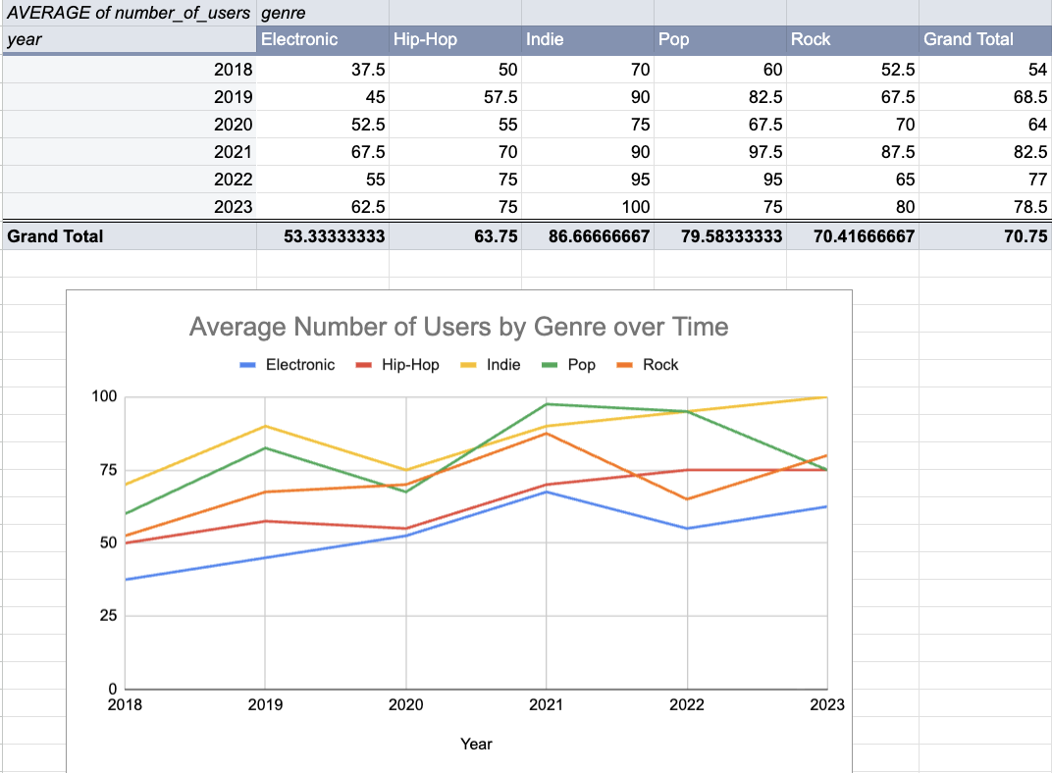
Recommendation
Fresh Beats should align content acquisition and promotional strategies with these genre trends:
- Prioritize acquiring more electronic and hip-hop tracks to capitalize on their steady upward trajectory.
- Maintain strong catalogue depth in indie and pop, since they attract the largest user bases and remain core pillars of engagement.
- Leverage rock music’s consistent audience for targeted campaigns, particularly when designing experiences aimed at converting free users.
- Use these genre insights to guide artist partnerships, playlist development, and targeted marketing tied to user listening patterns.
These steps ensure Fresh Beats expands in high-growth areas while sustaining engagement in the genres with the broadest appeal.

INSIGHT AND RECOMMENDATION
Insights  The chart clearly shows that paid users consistently listen to significantly more tracks than free users, and the gap widens every year from 2018 through 2023. While free-user engagement grows gradually, paid-user engagement accelerates faster, indicating that once users upgrade, they become highly active and remain long-term listeners.  This pattern highlights two key points:  - Paid users deliver higher value and stronger retention.  - High-engagement free users have strong potential to convert, since increased listening often predicts readiness to upgrade. |  |  | Visual B: Tracks listened to by the user  over time  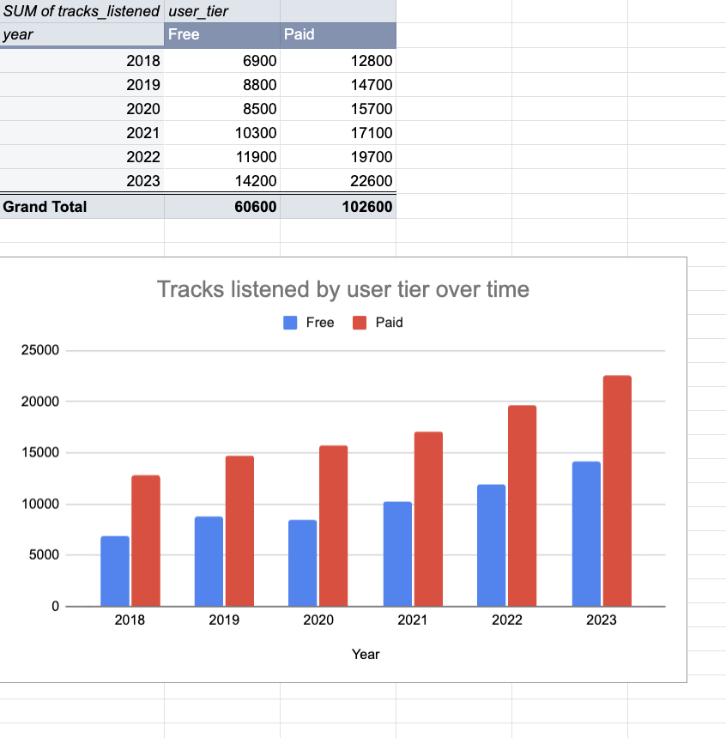
Recommendations
To capitalize on this behavior, Fresh Beats should focus on converting the most active free users by offering them personalized upgrade pathways.
Consider:
- Tiered conversion prompts based on listening volume, nudging high-activity free users toward paid benefits.
- Short-term upgrade trials showcasing premium features, since data shows paid listeners significantly increase platform usage after upgrading.
- Referral rewards that let free users access paid features temporarily when they bring in new listeners.
- Genre-specific upgrade incentives, especially for free users who repeatedly engage with high-volume genres like rock or pop.
These strategies not only encourage conversion but also strengthen retention, leveraging the engagement patterns already evident in the data.

INSIGHT AND RECOMMENDATION
Insights  The stacked bar chart shows clear differences in listening behavior between free and paid users across all genres from 2018 to 2023. Paid users consistently generate significantly higher total listens, and this gap widens each year.  Across both tiers, indie, pop, and rock make up the largest share of listens, while electronic and hip-hop show steady and notable growth year over year.  Key patterns:  - Paid users demonstrate higher engagement in every genre, indicating deeper usage once subscribers upgrade.  - Indie and pop explode in listen counts among paid users, particularly from 2021 onward.  - Rock remains a stable anchor genre for both tiers, especially free users.  - Growth in electronic and hip-hop signals rising interest and opportunity for expanding catalogue depth. |  |  | Visual C: Listens by genre and user  tier over time  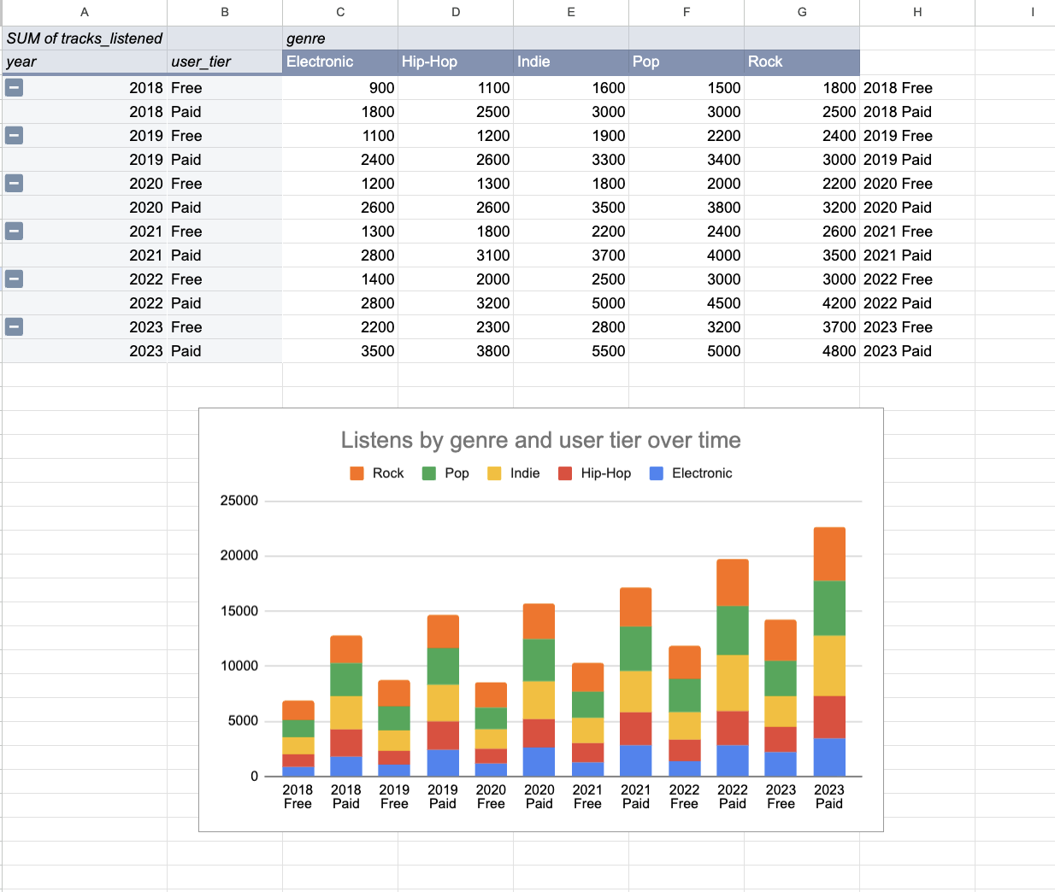
Recommendations
To maximize growth and conversion opportunities, Fresh Beats should tailor strategies around these insights:
- Use rock as a gateway genre for conversion campaigns targeted to free users, since their listening behavior consistently clusters here.
- Expand content in indie, pop, electronic, and hip-hop, as these genres drive high engagement among paid users and can be leveraged for retention and premium experience marketing.
- Create genre-specific upgrade prompts, such as paid-only playlists for indie and pop fans, where paid-tier listen counts significantly outpace free users.
- Prioritize promotional partnerships with artists in high-growth genres like electronic and hip-hop to reinforce the platform’s appeal for both new and existing users.
- Design listening challenges or curated weekly drops in genres with rising interest, highlighting the enhanced experience users receive once they upgrade.
By aligning catalogue decisions and marketing efforts with these listening trends, Fresh Beats can attract new listeners, strengthen conversion, and retain high-value paid subscribers.

CONCLUSION
Fresh Beats should expand its catalogue in electronic and hip-hop, as both genres show steady growth and offer strong potential for long-term engagement. Maintaining depth in indie and pop is essential because they attract the largest audiences and drive significant activity among paid users. Rock remains a reliable anchor genre, making it an ideal focus for targeted campaigns aimed at converting free users into paid subscribers. By aligning content acquisition, playlist strategy, and promotional efforts with these listening trends, Fresh Beats can boost engagement, strengthen retention, and increase free-to-paid conversions

